Floyd warshall

All pair shortest path algorithm..

This algorithm handle negative wt. But NOT negative weighted cycle....(as distance keep on decresing as we move in loop only)

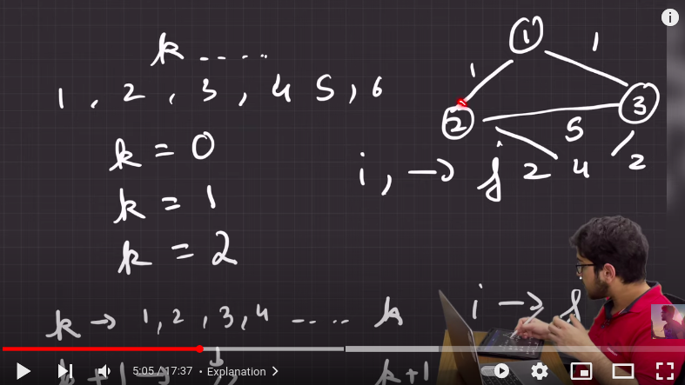

Here, k is the no. of vertex we through which we are reahing specified nodes (i----> j)

If we have, min length through (k-1) nodes and we are ,now taking k nodes , Now two case arrises:

1. if path lenth is same of more than through k ---> No change
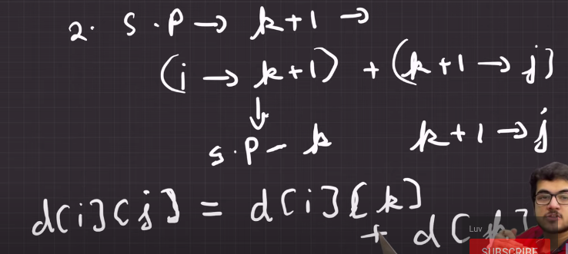
2. if path length through k node is less than throuh (k-1) nodes, then

In case of negative wt. We can add a condition : INF wali
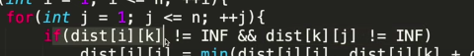

I/P O/P
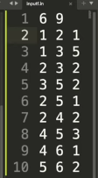
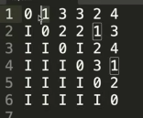

code:

#include<bits/stdc++.h>
using namespace std;
const int N = 1e3;
const int INF = 1e9;

int dist[N][N];

int main(){
for( int i=0 ;i<N ; i++){
for( int j=0 ; j<N ; j++){
if( i==j) dist[i][j]=0;
else dist[i][j]=INF;
}
}

int n, m; cin >> n >> m ;
for( int i=0 ; i< m ; i++){
int x, y, wt;
cin >> x >> y >> wt;
dist[x][y]=wt;
}

for( int k=1 ; k<= n ; ++k){ // k is no. of vertex passing through
for( int i=1 ; i<= n ; i++) {
for( int j=1 ; j<=n ; j++){
if( dist[i][k] != INF and dist[k][j] != INF){ //for neg. wt. checking
dist[i][j] = min( dist[i][j] , dist[i][k]+ dist[k][j]);
}
}
}
}

for( int i=1 ; i<= n ; i++) {
for( int j=1 ; j<=n ; j++){
if(dist[i][j] == INF){
cout<<"I"<<' ';
}
else cout<<dist[i][j]<<' ';
}
cout<<"\n";
}
}

